We have a number of discounted accommodations options to choose from.
Please ensure you mention the booking code / reference at time of booking.
O'Rourke Hall - 16 Mount Street, Auckland
Email: louise.newbury@auckland.ac.nz
Phone: 09 923 5678
Booking Code: RELI
Single room - includes linen. Shared bathroom.
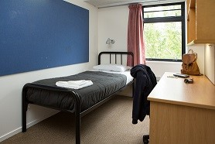
Copthorne Auckland City Hotel - 150 Anzac Ave, Auckland
To book Via Website - https://www.millenniumhotel.com
Website Booking Code: NZASR18
To book Via Email or Phone
Email: Copthorne.aucklandcity@millenniumhotels.co.nz
Phone: 09 379 8509
Booking Block Number: 5515135
Superior Room - $185.00
Rates include wifi & GST
Discount breakfast $18.00 per person
Terms & Conditions
Cancellation Policy - 24 hours prior to check in.
A credit card is required at the time of booking. Rates include gst.
Booking are subject to availability
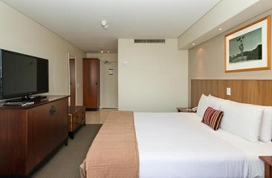
Quadrant Hotel
Email: quad.reservations@vrhotels.co.nz
Phone: 0800666611 or 09 9846010
Booking Code: RJC 2018
Deluxe Queen - $245.00
1 Bedroom Classic - $265.00
1 Bedroom Premier - $275.00
Rates include unlimited wifi
Terms & Conditions
Rates are Nett/Non-Commissionable- subject to availability.
Rates quoted in NZD - inclusive of 15% Goods and Service Tax. Rates are subject to a change in case tax rate changes.
For group bookings - acceptance on the contracted rate will be at the discretion of the property and subject to availability.
Cancellation Policy: No cancellation fee applies if nominated representative or agent notifies the reservations department (in writing)
of the cancellation 24 hrs. prior to the day of arrival date.
A 24-hour period is deemed as 24 hours prior to check in time at the property - 3 pm.
Any cancellations within 24 hours of arrival will incur a cancellation fee of one full night’s accommodation
